 |  |  |  |  | 16 Sep 2025  - Quarter Major Housiau, PEUTIE  Special Operations Regiment Change of Command  SO Regt HQ & 6 Gp CIS  Additional information for guests

change of command parade SO Regt HQ & 6 Gp CIS CO
11.00  - 11.45 |  |  |  |   Arrival and welcome coffee  At the old Canteen 1Para of the Citadel of Diest  Meet and Greet with the Anciens Congo ‘64
12.00  - 13.15 |  |  |  | Start of the ceremony  Parade including the Change of RSM SO Regt.  13.15 – 13.45 Shift to SCHAFFEN.
13.45  - 17.45 |  |  |  | reception and standing lunch  Drinks and food @ Training Centre Para Schaffen.  17.45 End of the event.
Location |  |  |  |  |  |  | DRESS CODE & Payment
- Event: Quarter Major Housiau, PEUTIE  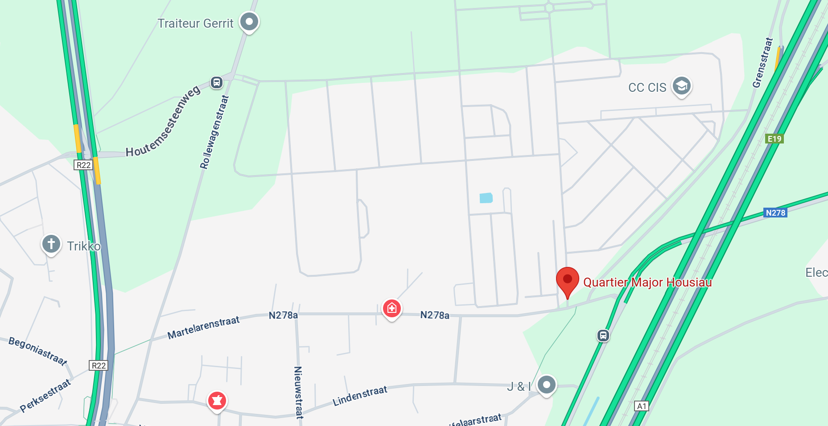  - Reception & Standing Lunch: Training Centrum Parachutisten SCHAFFEN, Karrestraat 1, Diest |  |  |  |  |  |  | Dress Code:  For Military guests: Service Dress  For Civilian guests: Formal Business (tie)  Payment:  Please register by paying 35€ on the account BE16 0012 0058 6174 (Serv part HQ SO Regt)  Communication: SO Regt Parade / Name / First name  You will receive a confirmation e-mail afterwards.  More questions: HQSOREGT-Srt@mil.be

