 |  |  |  |  | 16 Sep 2025  - Major Housiau Barracks, PEUTIE  Special Operations Regiment Change of Command  COM & COS SO Regt - CO 6 Gp CIS  Additional information for guests

change of command parade SO Regt HQ & 6 Gp CIS
14.30  - 15.00 |  |  |  | Welcome Invitees  Paradeground Peutie Barracks
15.00  - 16.15  16.15  - 17.30  17.30  - 20.00 |  |  |  |   Inauguration Ceremony  COM, COS SO Regt & CO 6 Gp CIS  Reception  Bloc D4  Dinner  Bloc D4
Location |  |  |  |  |  |  | DRESS CODE & Payment
Event: Major Housiau Barracks, PEUTIE  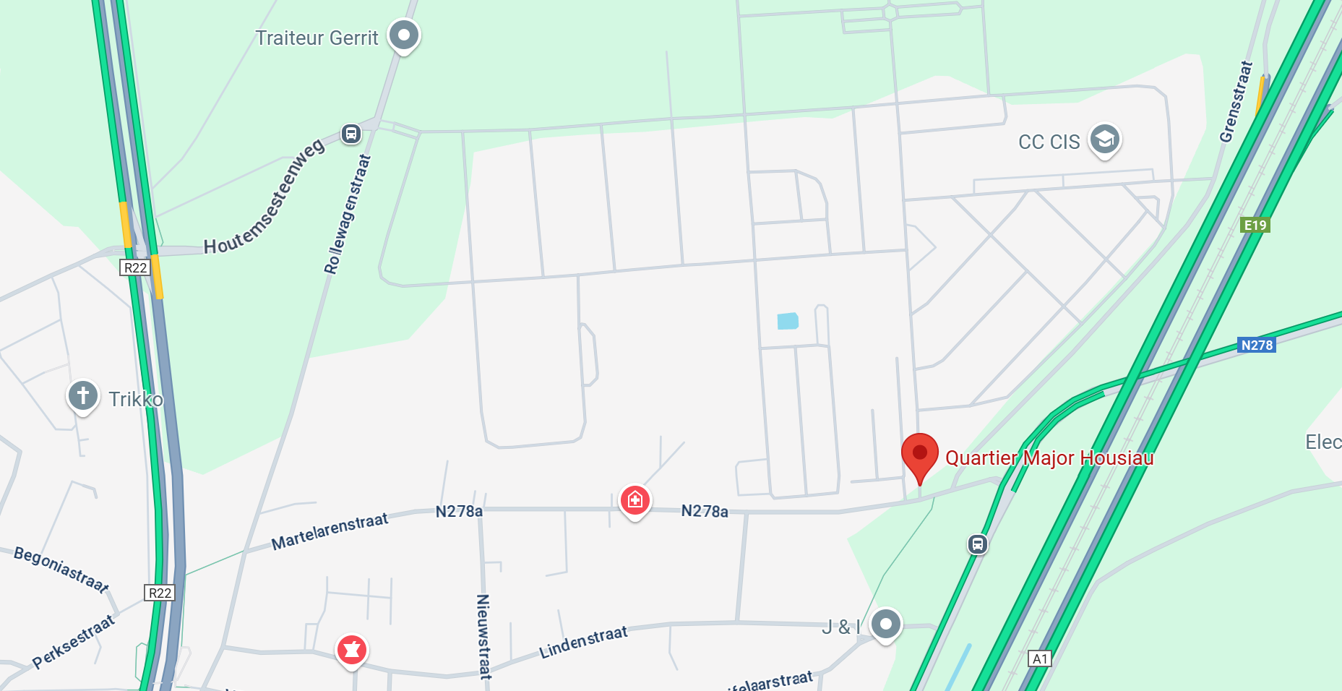 |  |  |  |  |  |  | Dress Code:  - For Military guests: Service Dress  - For Civilian guests: Formal Business (tie)  Payment:  Please register by paying 17,50€ or 45€ on the account BE02 0003 1706 7940 (SCV 6 Gp CIS)  Communication: SO Regt CoC/ Name / First name / Rank  You will receive a confirmation e-mail afterwards.  More questions: 6gpcis-events@mil.be

