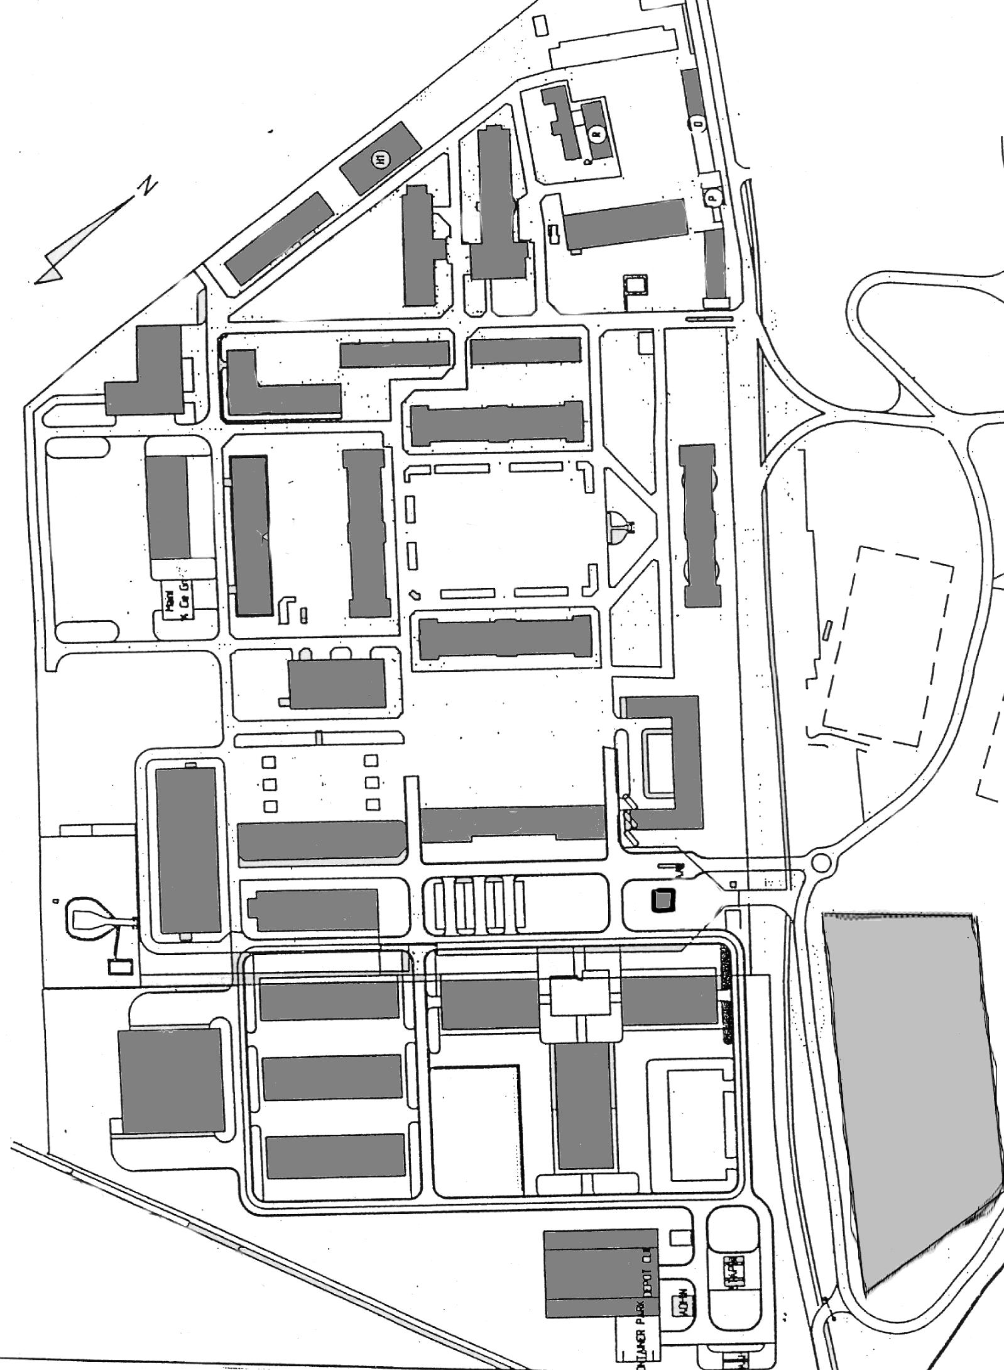

**2**

**4**

**1**

**3**

1. Parking 2. Parking VVIP 3. Guard House 4. Salle/Zaal