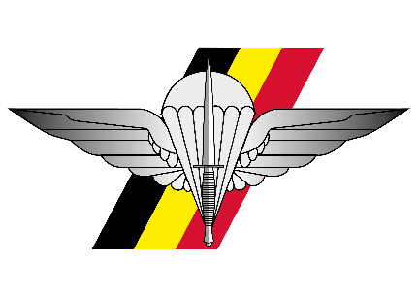 | 18 DEC 2025  - Auditorium Malmedy, Evere  Academic session organized by SPIRIT  Additional information

PROGRAM | Academic session

13.00  - 13.30 | Welcome  Coffee
13.30  - 13.45 | Guests in place  Introduction
13.45  - 15.00 | 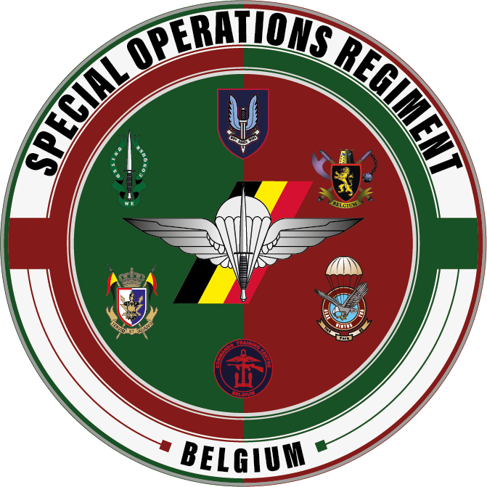  Conference
15.00  - 15.30 | Q&A
15.30  - 17.00 | RECEPTION

LOCATION | DRESS CODE & PAYMENT
Queen Elisabeth Barracks, Bloc 4A,  Everestreet 1, 1140 Evere.  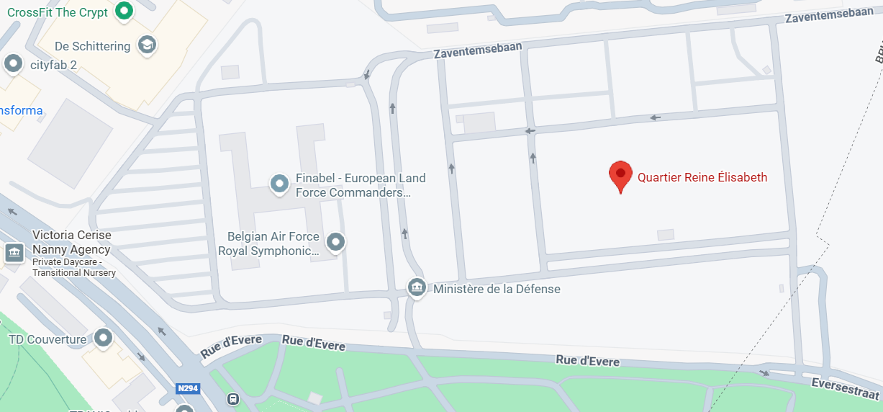 | Dress Code:  - For Military guests: BDCS  - For Civilian guests: Business casual  Payment:  Please register by paying:  - 5€ (reception only)  on the account BE73 9501 8582 5760 (Royal Assoc ParaCdo Offr)  Communication: AS 2025 – NAME  You will receive a confirmation e-mail afterwards.  More questions: hqsoregt-srt@mil.be

