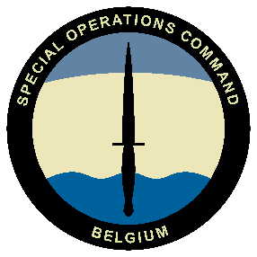 | 18 DEC 2025  - Auditorium Malmedy, Evere  SOF NEXUS organized by SOCOM  Academic session organized by:  - The Special Operations Regiment  - The Royal Association Para-Commando Officers  Additional information

PROGRAM | AM - SOF NEXUS | PM - Academic session

08.30  - 09.00 | welcome  With coffee in the lobby next to Malmedy room
09.00  - 11.30 | TOPICS BROUGHT BY Dir SOCOM & COM SO REGIMENT  - SOCOM and SOR: Where do we stand, outlook  - SOF: the operational focus  - SOF: Lessons, limits, and leverage  - SOF Innovation  - Closing speaker
11.30  - 12.30 | LUNCH  Sandwich in the lobby
13.00  - 13.30 | Welcome  Coffee
13.30  - 13.45 | Guests in place  Introduction
13.45  - 15.00 | Conference
15.00  - 15.30 | 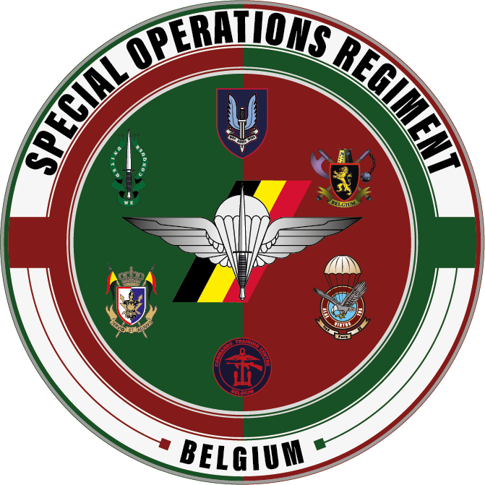  Q&A
15.30  - 17.00 | RECEPTION

LOCATION | DRESS CODE & PAYMENT
Queen Elisabeth Barracks, Bloc 4A,  Everestreet 1, 1140 Evere.  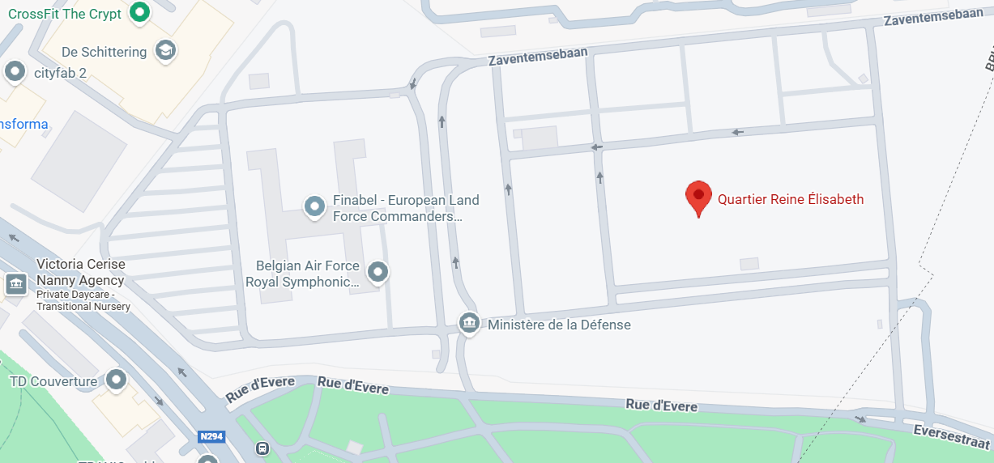 | Dress Code:  - For Military guests: BDCS  - For Civilian guests: Business casual  Payment: Free  A security clearance BEL Secret is required. Verification will be done before the event by the sending unit. No need to bring a PSCC to the event.  More questions: hqsoregt-srt@mil.be

