28 MAY 2026
LTG VINCENT DESCHEEMAEKER’S
FAREWELL TO ARMS
HOSTED BY
THE SPECIAL OPERATIONS REGIMENT

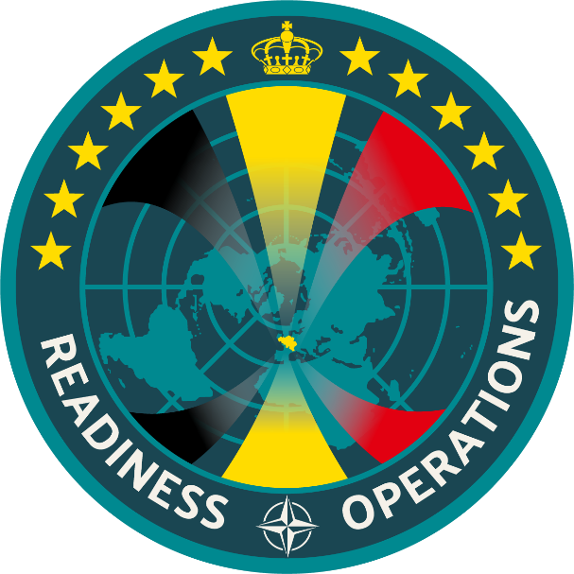

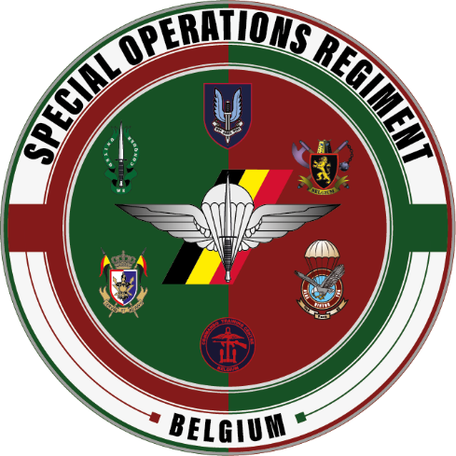
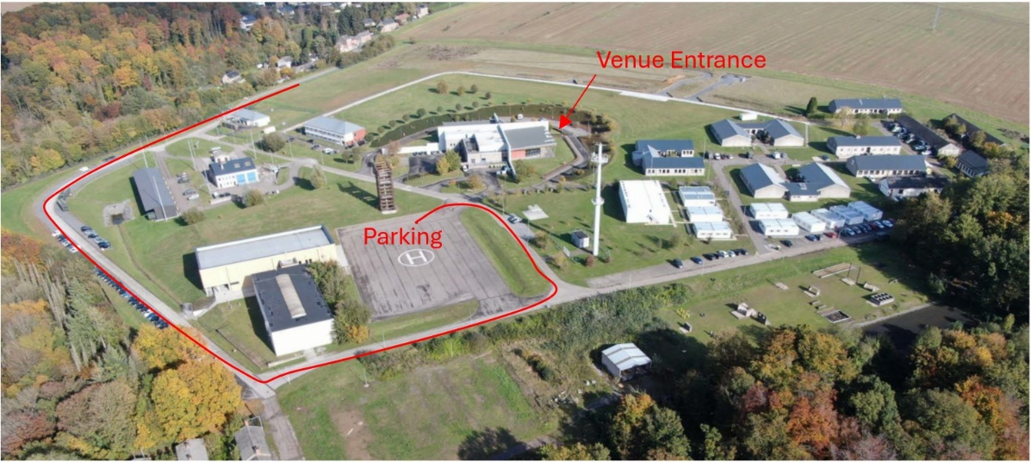
DRESS CODE
BDCS (COMBAT UNIFORM)
OR BUSINESS CASUAL
PAYMENT
XX€ BE89 0637 8962 3885

PROGRAMME

1830 GUESTS ARRIVAL
1915 FAREWELL SPEECH – LTGEN DESCHEEMAEKER
1945 STANDING DINER
2030 TRIBUTE SPEECH – TBC
2045 CONCERT FLORIS & THE FLAMES
2230 END

LOCATION
BARRACK WARTET
RUE AUX VALLÉES, 43
5024 MARCHE-LES-DAMES

