28 MAY 2026
LTG VINCENT DESCHEEMAEKER’S
FAREWELL TO ARMS
HOSTED BY
THE SPECIAL OPERATIONS REGIMENT

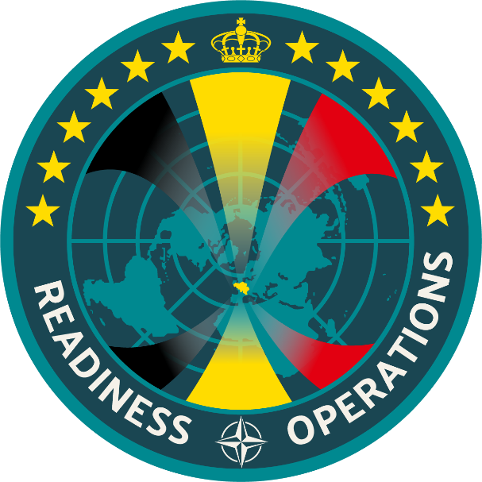

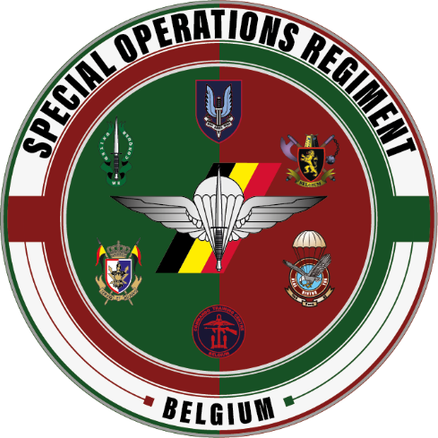
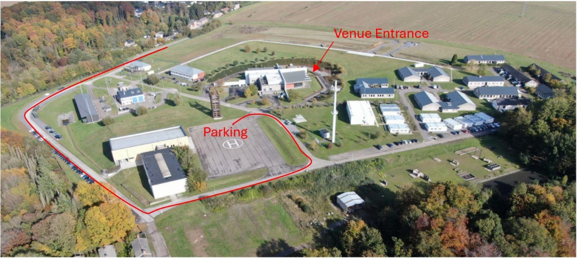
YOUR PRESENCE WILL BE ENOUGH OF A GIFT, COME EMPTY-HANDED AND ENJOY THE EVENT!
DRESS CODE
BDCS (COMBAT UNIFORM)
OR BUSINESS CASUAL
PAYMENT BEFORE 18 MAY 2026
10€ BE89 0637 8962 3885
COMMENT: 28 MAY 2026 – NAME - 1st NAME

PROGRAMME

1830 GUESTS ARRIVAL
1915 FAREWELL SPEECH – LTGEN DESCHEEMAEKER
1945 STANDING DINNER
2030 TRIBUTE SPEECH
2045 LIVE CONCERT
2230 END

LOCATION
BARRACK WARTET
RUE AUX VALLÉES, 43
5024 NAMUR

