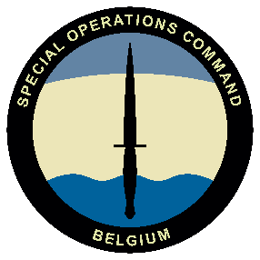 | 04 SEP 2026  - Meeting room Blondeel, Heverlee  SOF VANGUARD organized by  - SOCOM  - The Special Operations Regiment  Additional information

PROGRAM | SOF NEXUS VANGUARD

08.30  - 09.00 | welcome  With coffee in the meeting room Blondeel.
09.00  - 12.00 | TOPICS BROUGHT BY Dir SOCOM & COM SO REGT  - SOCOM and SO Regt: Where do we stand; Outlook;  - SOF: Leadership;  - SOF: The operational focus;  - …
12.00  - 13.00 | 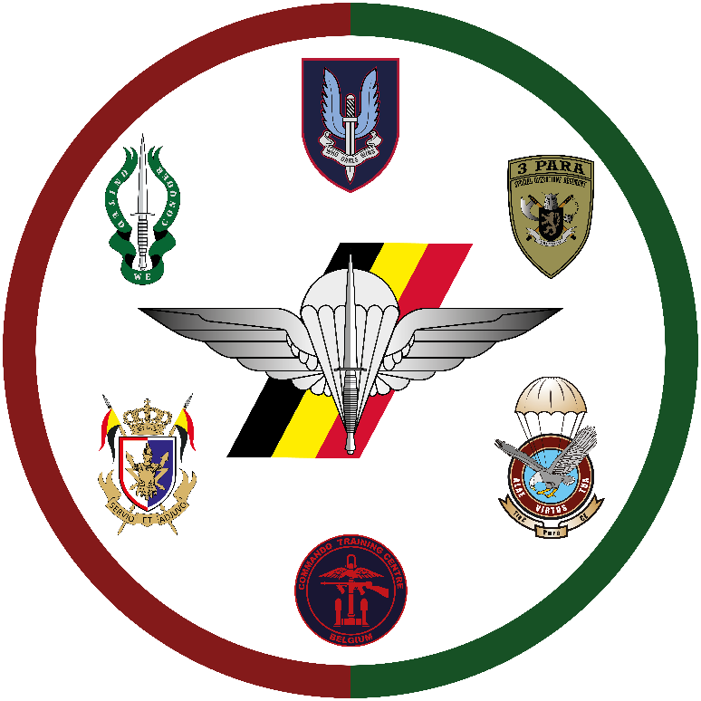  LUNCH  Possible in Mess Heverlee (pay for yourself).

LOCATION | DRESS CODE
Quartier Cdt De Hemptinne, Hertogstraat 184,  3001 Heverlee, meeting room Blondeel.  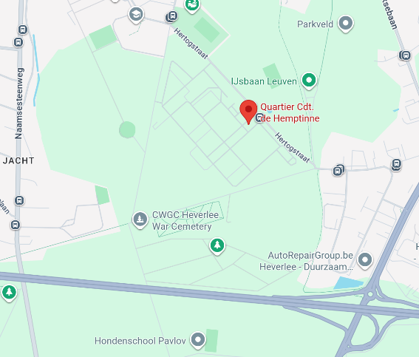 | Dress Code: BDCS  Payment: Free  A security clearance BEL Secret is required. Verification will be done before the event by the sending unit. No need to bring a PSCC to the event.  The SOF NEXUS Vanguard is only open to OF1 & OF2  (SLT – 1LT – CPT).  More questions: ACOSRO-SOCOM-Srt@mil.be

