 | 16 SEP 2026  - Barracks Heverlee  Change of Command organized by  - Special Forces Group  Additional information

PROGRAM | SF Gp Change of Command

13:30  - 14:00  14:00  - 14:15 |  | welcome  Parade Ground  guest in place  Parade Ground
14:15  - 14:45 |  | 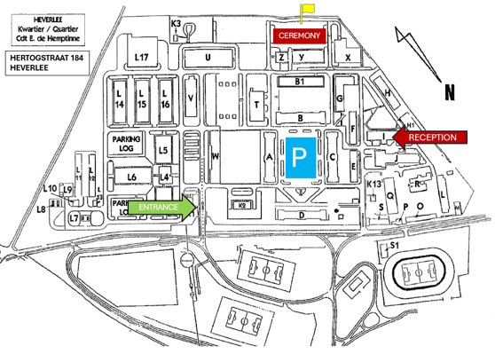  Ceremony  - Parade  - Speech
15:00  - 18:00 |  | Reception & Standing Lunch  Heverlee Barracks – Blok I
 | LOCATION |  | DRESS CODE
 | Quartier Cdt De Hemptinne  Hertogstraat 184  3001 Heverlee  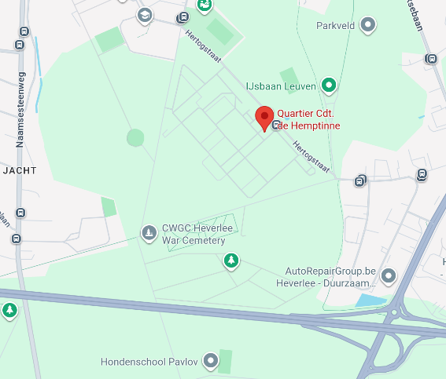 |  | Dress Code:  - Military: Service Dress  - Civilian: Tenue de ville – Business attire  Payment:  Participants attending the reception are kindly requested to transfer € 10 Per Person to the following account: BE33-0003-2512-9246 (Reference: 16 Sep 2026 - SURNAME - FIRST NAME).  Participants attending the reception and standing lunch are kindly requested to transfer € 25 Per Person to the following account: BE33-0003-2512-9246 (Reference: 16 Sep 2026 - SURNAME - FIRST NAME).  Participants attending only the parade do not need to make any payment.  More questions: SFGP-Srt@mil.be

