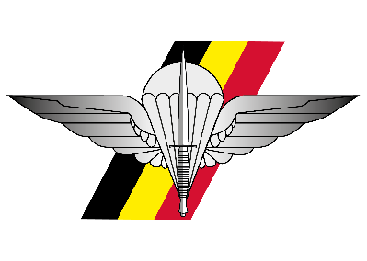 |  |  |  |  | 11 Oct 2024  - Citadel, DIEST  Special Operations Regiment Change of Command  Red and Black Dragon Congo 1964 Commemoration  Additional information for the Anciens of ‘64

60 jaar Rode Draak en Zwarte Draak

60 ans Dragon Rouge et Dragon Noir
09.15  - 10.00 |  |  |  | ARRIVAL and welcome coffee  At the Cinema of the Citadel of Diest.
10.00  - 11.30 |  |  |  | Academic session red and black dragon  The story of Congo ’64 with several guest speakers, at the Cinema of the Citadel.  Followed by a coffee offered at the old canteen 1Para.

Special operations regiment change of command parade
12.00  - 13.15 |  |  |  | Start of the ceremony  Parade including the Change of RSM SO Regt.  13.15 – 13.45 Shift to SCHAFFEN.
13.45  - 17.45 |  |  |  | reception and standing lunch  Drinks and food @ Training Centre Para Schaffen.  17.45 End of the event.
On request only, the SO Regt can provide transportation from the train station of Diest to the Citadel, from the Citadel to Schaffen and back to the train station after the lunch. Please contact the e-mail below or call +3224434514
Location |  |  |  |  |  |  | DRESS CODE & Payment
- Event: Citadel, DIEST  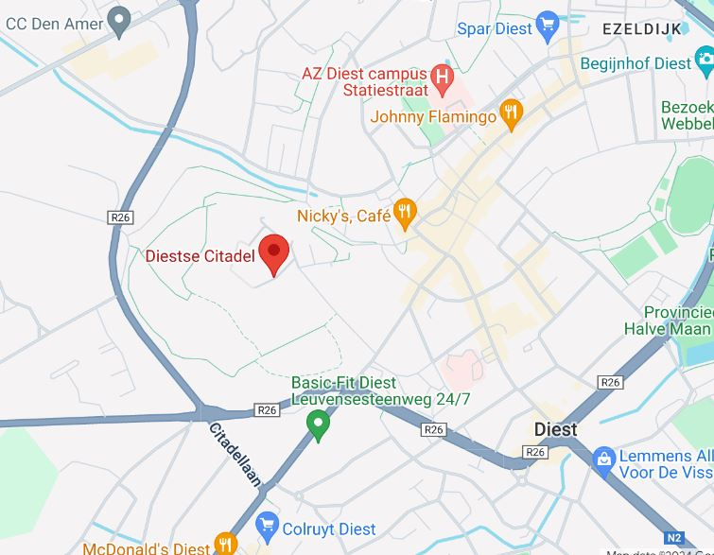  - Reception & Standing Lunch: Training Centrum Parachutisten SCHAFFEN, Karrestraat 1, Diest |  |  |  |  |  |  | Dress Code:  For Military guests: Service Dress  For Civilian guests: Formal Business (tie)  Payment:  Please register by paying 35€ on the account BE16 0012 0058 6174 (Serv part HQ SO Regt)  Communication: SO Regt Parade / Name / First name  You will receive a confirmation e-mail afterwards.  More questions: HQSOREGT-Srt@mil.be

